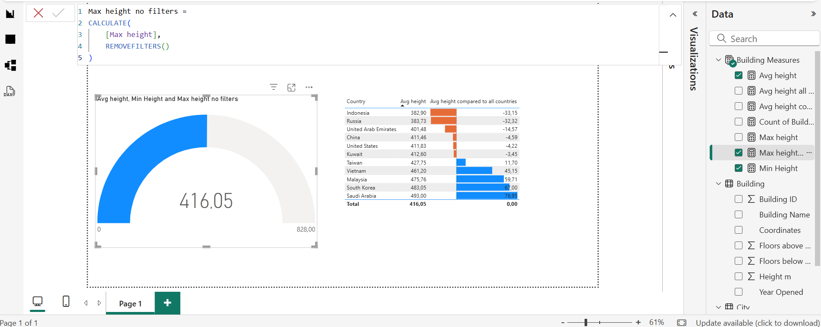
Computing Maximum Height of the buildings with no filters using CALCULATE, REMOVEFILTERS

